**Here is the Data Modelling for my Project:**

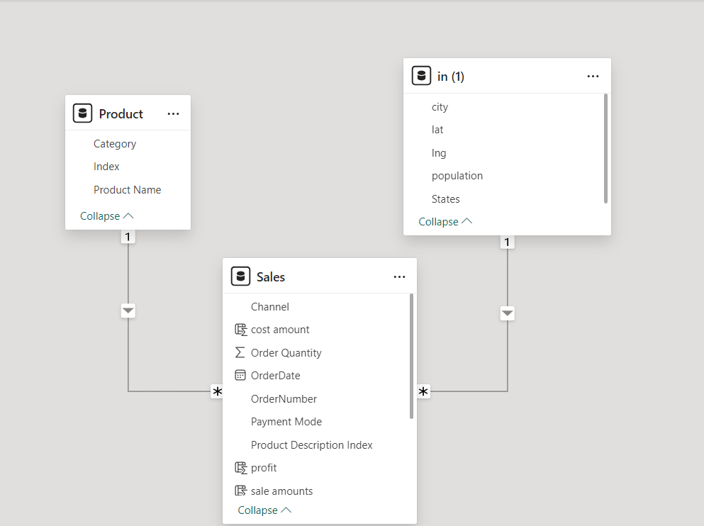

## Linkedln Post [: https://www.linkedin.com/in/sagar-jare/recent-activity/all/](:%20https://www.linkedin.com/in/sagar-jare/recent-activity/all/)

**𝐓𝐨𝐨𝐥𝐬 𝐚𝐭 𝐖𝐨𝐫𝐤:**

* Excel & Power Query for robust data cleansing and transformation.
* Power BI for dynamic visualizations and predictive analysis.
* Microsoft PowerPoint for crafting engaging presentations.

**Interpretation**:   
📈 **2021 Highlights:** 🏆 Wholesale led in profits, making ₹1,00,79,160, which is 51% of the total profit. 📆 March was the best month, with sales of ₹55,38,079, 60% higher than January.

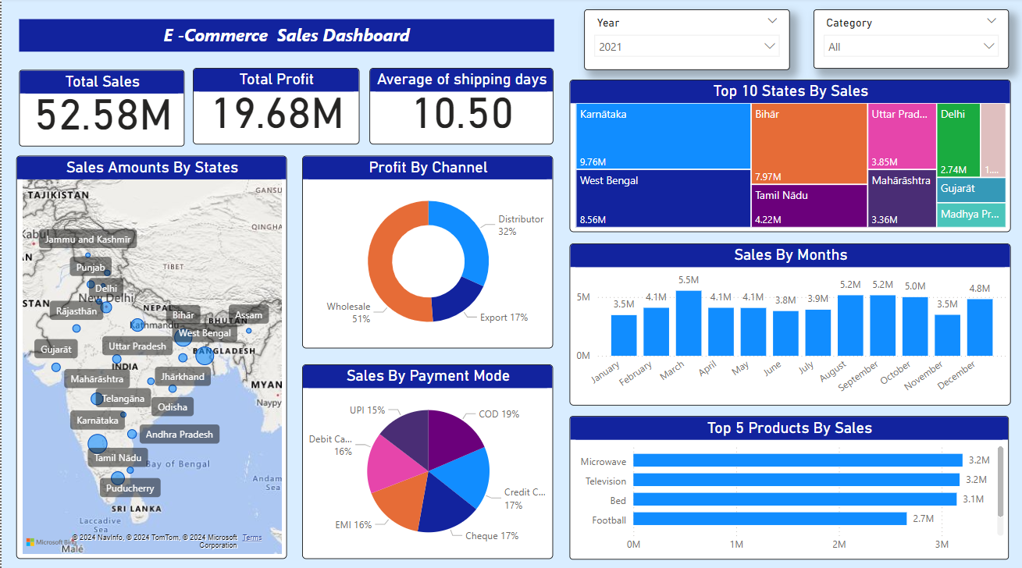

📊 **2022 Highlights:** 💰 Wholesale remained on top, earning ₹1,09,75,972 constituting 55% of the total profit. December had the highest sales at ₹51,20,622 a significant 32% increase from April.  
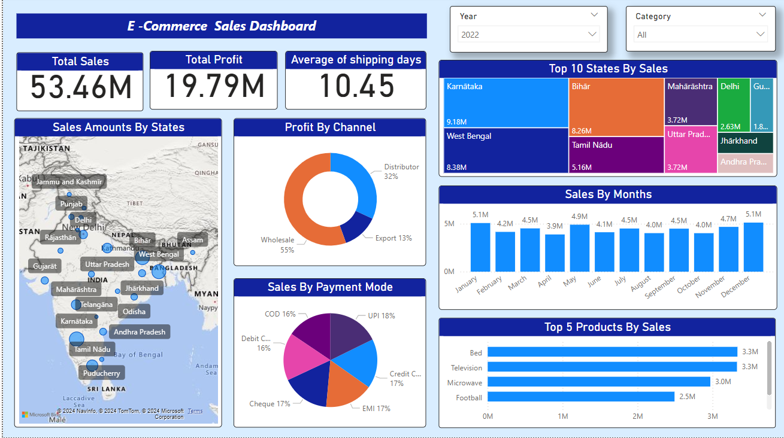

📅 **2023 Highlights:** 🚀 Wholesale kept its profit lead at ₹96,79,354 making up 53% of the total profit. 📊 November was the top sales month, hitting ₹45,29,394 an impressive 137% increase from December.

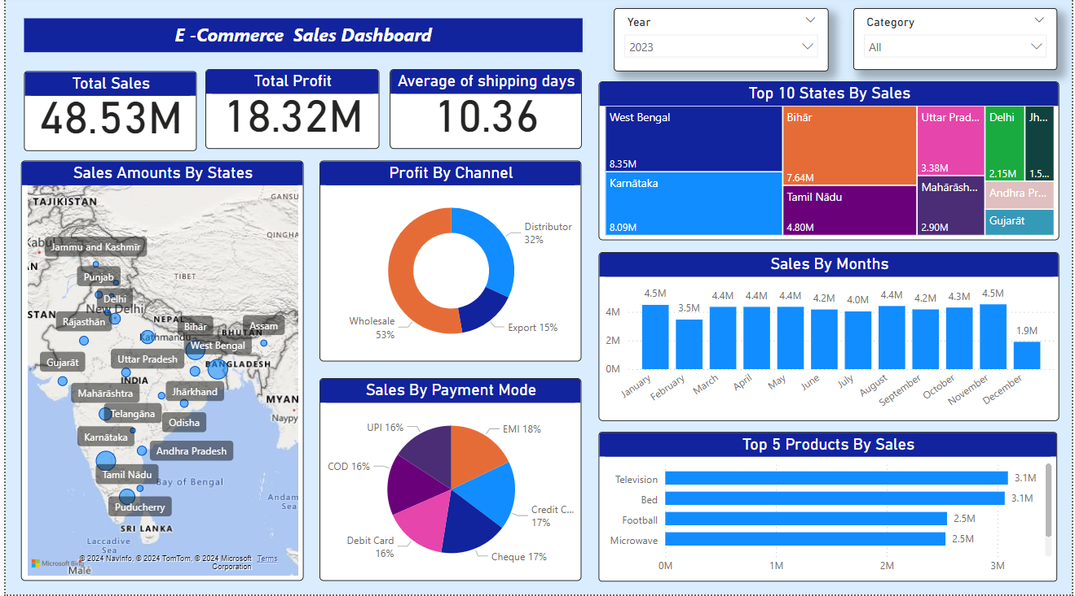  
  
🌐 Throughout the E-commerce journey, Wholesale consistently led in profits. 📈💡  
  
Key Takeaway: Understanding these monthly sales trends is crucial for strategic planning in the ever-changing E-commerce world.